**A Git repository hosted locally (or use GitHub for simplicity)**

**Step 1: Install Git:** Git is a version control tool used to manage and interact with repositories hosted on GitHub. So we installed git on our system and checked the git version.

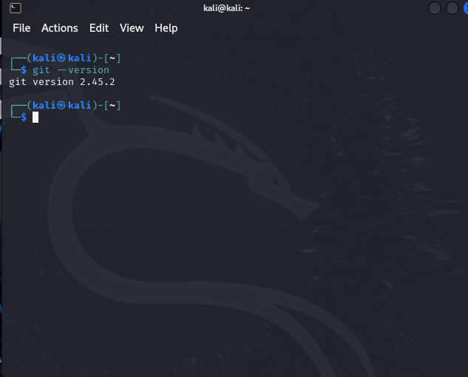

**Step 2: Simple Java Code:** Once we installed git then we created a simple java program.

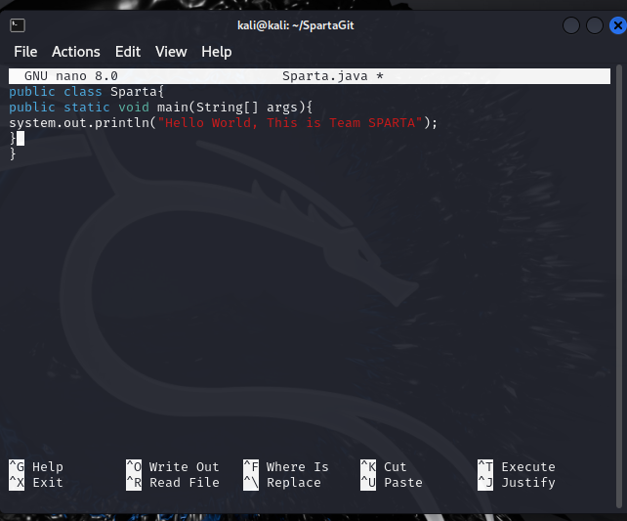

Step 3: Add and Commit: We added the file that we created and gave the description.

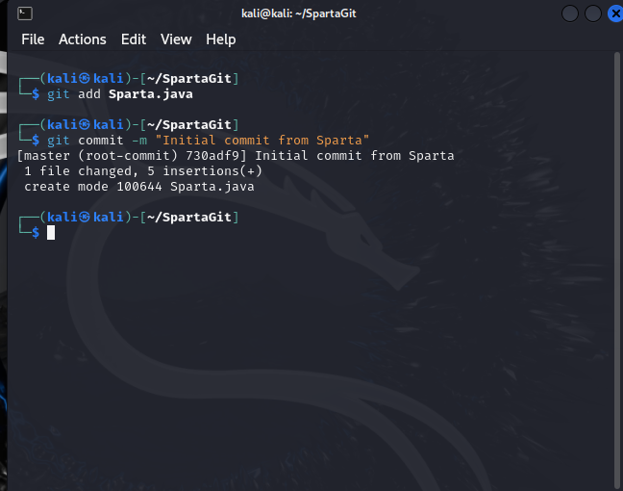

Step 4: In this step we created the repository in GitHub and pushed our code to the repository.

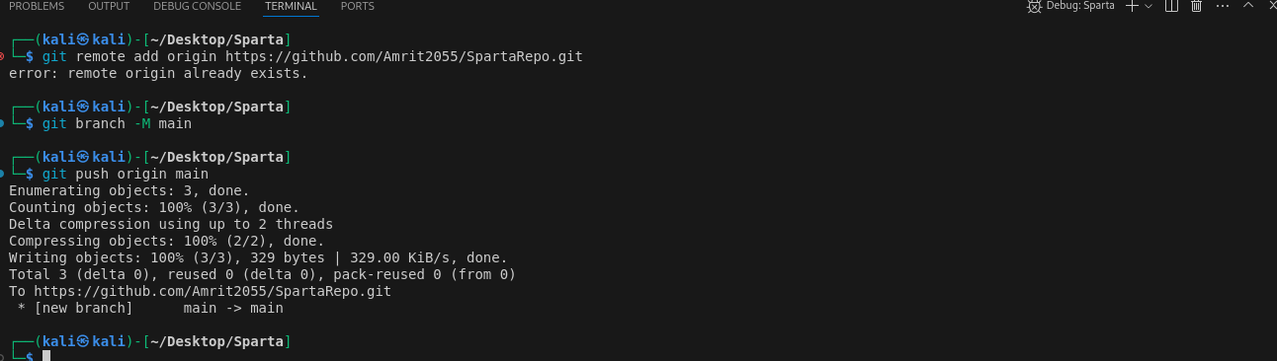

Step 5: Once the code is pushed to the GitHub Repository, we can see the changes in our GitHub account.

